Report 2 Part 1
Pool Control System

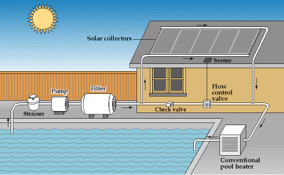
by Unknown Author is licensed under

Team BST – Members:
Steven Rioux
Taft Barrott
Brenton Dube

